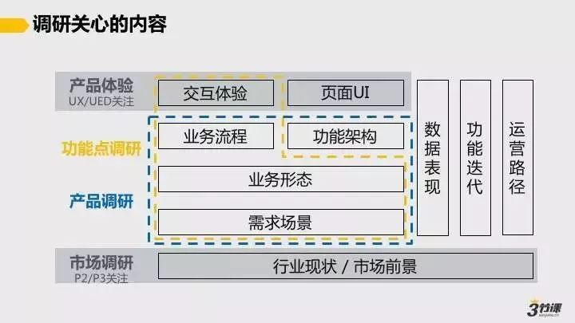

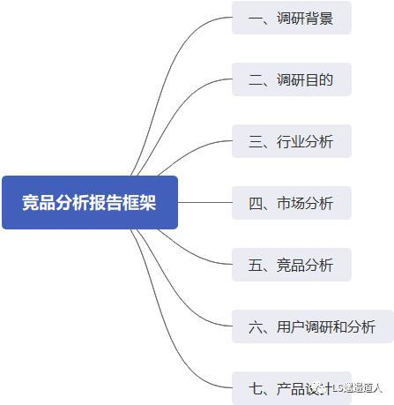

<https://www.sohu.com/a/392126985_445379>

<https://www.meadin.com/info/160179.html>

https://www.uisdc.com/simplify-the-operational-process-summary

**（1）用户画像框架**

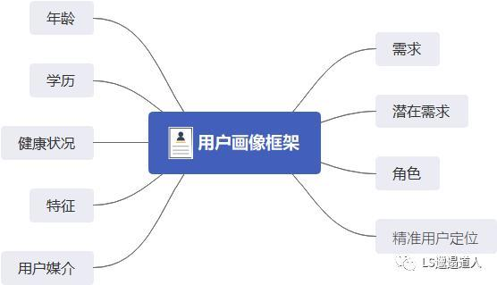

**（2）问卷调查设计框架**

